


Thank you for your support to share Jesus’ message of hope to millions of people.
Please use any of the following in your bulletins, newsletters and worship service announcements to let people know about videos, radio messages and resources that are available to help them personally and for them to share with others. Thank you


Listen to Messages of Hope at www.messagesofhope.org.au & www.messagesofhope.org.nz or on iTunes and Spotify.

3rd October Peace beyond reason (Rev Noel Due)
Are you at peace? This week Noel Due will be talking about Peace. Not the dream of world peace, but about inner peace. Peace that works even when the world, and perhaps even you, are in chaos.

10th October It’s ok to feel anxious (Anna Doecke)
What's the difference between worry and anxiety and how do we stop being overwhelmed by things we can't control? This week we're talking about worry and anxiety with Anna, a counsellor from Journeez.

17th October Send me an angel (Interview)
It'd be great if depression was purely logical. Follow three simple steps and everything will be okay! Although depression isn't simple, it doesn't mean it's hopeless. Jane shares about her depression and what it took to find motivation again.

24th October The hero servant (Rev David Altus)
Imagine the power you could have to do whatever you wanted. But is that way of life any good for us and is there a better way to live? This week David Altus will share about an experience he had that has helped him in life.

31st October Overwhelmed (Discussion)
Life can be crazy and chaotic at the best of times, even more so when we're in a pandemic. Listen to Anna, Celia and Richard discuss how we can live each day when the future is so uncertain.

ORDER YOUR FREE CALENDAR

The Lutheran Media Calendar is full of inspiring competition photos and great for gifts. Order your free calendar/s at www.lutheranmedia.org.au or call on 1800 353 350. Calendars will be delivered after production at the end of September.

MESSAGES OF HOPE CHRISTMAS CARDS
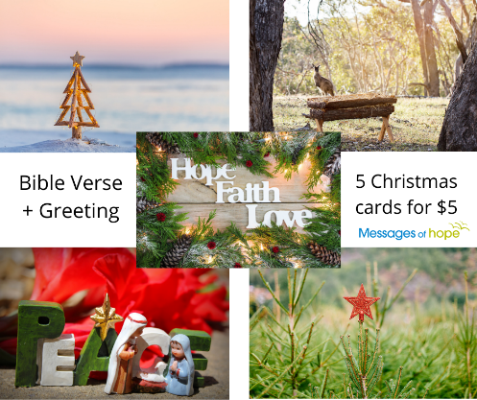
Hope-filled cards for Christmas, with bible verse and greeting. $5 per pack of 5 cards – variety of Christmas designs. Order yours at www.lutheranmedia.org.au or call 1800 353 350.

HAPPYLAND CHRISTMAS CARDS

Free Happyland Christmas Cards to give away to people in your community including family, friends, neighbours, and students. Order at www.happyland.com.au or call 1800 353 350.

BIBLE ON TRIAL

Check out how the Bible has withstood intense scrutiny from critics and cynics alike. Order and watch the DVD of The Bible On Trial: Beyond a Reasonable Doubt at www.lutheranmedia.org.au/bibleontrial. You’ll come away with a fresh appreciation of the Bible. The Bible on Trial DVD comes with a study guide. The DVD is $15 plus postage and handling.

WORSHIP ONLINE & DVDs
Online, DVD & CD worship services are available at www.lutheranmedia.org.au/worship or email luthmedia@lca.org.au or call 1800 353 350.


VIDEOS ON CURRENT TOPICS
The latest inspiring and encouraging video messages on anxiety, depression and wellbeing are on www.youtube.com/messagesofhope. Watch and share them with friends and family and on your social media channels.

PRAYER REQUESTS
- For people who are feeling afraid or anxious with the ongoing coronavirus pandemic.
- For people suffering from illness or separation from family
- For people suffering economic effects and homelessness
- For our Lutheran Media family and the people we are meeting through media outreach

FAMILY FUN AT HAPPYLAND.COM.AU
Enjoy the Happyland website game at www.happyland.com.au. Set up your own character, change them, and take them on an adventure. Go on to the App store and download the Happyland App for iPhone and iPad.
Happyland Stories videos are also available. They make great children’s messages.

REACH MILLIONS WITH HOPE
You can reach millions of people with hope, including people in your community. Join with Lutheran Media to offer people hope in Jesus Christ by giving a donation today. Together we can make a real difference in many people’s lives. Donate at www.lutheranmedia.org.au or call 1800 353 350. Thank you

REACH OUT WITH US ON SOCIAL MEDIA




