


Thank you for your support to share Jesus’ message of hope to millions of people.
Please use any of the following in your bulletins, newsletters and worship service announcements to let people know about videos, radio messages and resources that are available to help them personally and for them to share with others. Thank you


Listen to Messages of Hope at www.messagesofhope.org.au & www.messagesofhope.org.nz or on iTunes and Spotify.

7th November Surviving Tough Times (Discussion)
When things are going wrong we often ask why me? And when the tough times seem to just keep coming, how do we make sense of it? How do we cope when life gets tough?

14th November Fighting Fires (Interview)
Bushfires can be devastating. Even when you’re well prepared, they have a way of surprising you! Hear stories of what it’s like to survive a catastrophic bushfire. How do those on the fire ground make sense of a natural disaster like a bushfire?

21st November Dealing with Stress (Interview)
Life seems to be going 100 miles an hour, people all around us seem to be suffering from burnout and stress. This isn’t something new. But what is it that causes us to feel like it’s all just getting too much, and what helps us cope?

28th November Letting Go Of Control (Round Table)
Life can be crazy and chaotic at the best of times, even more so when we’re in a pandemic. Hear how we can live each day when the future is so uncertain.

SHORT MOVIE COMPETITION RESULTS
Thank you to all entrants. And congratulations to the winners! It was a very tight competition and we enjoyed watching all the movies. You can watch winning entries on www.youtube.com/messagesofhope

ORDER YOUR FREE CALENDAR

The Lutheran Media Calendar is full of inspiring competition photos and great for gifts. Order your free calendar/s at www.lutheranmedia.org.au or call on 1800 353 350. Calendars will be delivered after production at the end of September.

MESSAGES OF HOPE CHRISTMAS CARDS
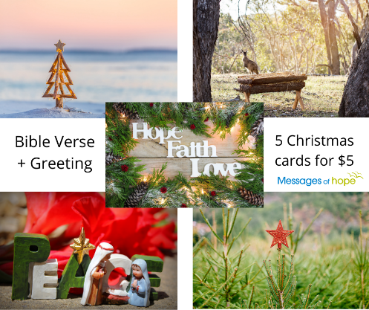
Hope-filled cards for Christmas, with bible verse and greeting. $5 per pack of 5 cards – variety of Christmas designs. Order yours at www.lutheranmedia.org.au or call 1800 353 350.

HAPPYLAND CHRISTMAS CARDS

Free Happyland Christmas Cards to give away to people in your community including family, friends, neighbours, and students. Order at www.happyland.com.au or call 1800 353 350.

BIBLE ON TRIAL

Check out how the Bible has withstood intense scrutiny from critics and cynics alike. Order and watch the DVD of The Bible On Trial: Beyond a Reasonable Doubt at www.lutheranmedia.org.au/bibleontrial. You’ll come away with a fresh appreciation of the Bible. The Bible on Trial DVD comes with a study guide. The DVD is $15 plus postage and handling.

WORSHIP ONLINE & DVDs
Online, DVD & CD worship services are available at www.lutheranmedia.org.au/worship or email luthmedia@lca.org.au or call 1800 353 350.


VIDEOS ON CURRENT TOPICS
The latest inspiring and encouraging video messages on anxiety, depression and wellbeing are on www.youtube.com/messagesofhope. Watch and share them with friends and family and on your social media channels.

PRAYER REQUESTS
- For people who are feeling afraid or anxious with the ongoing coronavirus pandemic.
- For people suffering from illness or separation from family
- For people suffering economic effects and homelessness
- For our Lutheran Media family and the people we are meeting through media outreach

FAMILY FUN AT HAPPYLAND.COM.AU
Enjoy the Happyland website game at www.happyland.com.au. Set up your own character, change them, and take them on an adventure. Go on to the App store and download the Happyland App for iPhone and iPad.
Happyland Stories videos are also available. They make great children’s messages.

REACH MILLIONS WITH HOPE
You can reach millions of people with hope, including people in your community. Join with Lutheran Media to offer people hope in Jesus Christ by giving a donation today. Together we can make a real difference in many people’s lives. Donate at www.lutheranmedia.org.au or call 1800 353 350. Thank you

REACH OUT WITH US ON SOCIAL MEDIA







