Messages of Hope in February 2024

4th February | 50 Years of Loving | (Interview)
Through the ups and downs of 50 years of marriage, Sue shares her secret to a long and fulfilling relationship.
11th February | Language of Love | (Interview)
Relationships are hard work sometimes. Often it comes down to communication. Julie and Chris share stories on relationship ups and downs and how understanding the way we show our love can help us to turn our relationships around.
18th February | Fighting Fires | (Interview)
Bushfires can be devastating. Even when you’re well prepared, they have a way of surprising you! Hear stories of what it’s like to survive a catastrophic bushfire. How do those on the fire-ground make sense of a natural disaster like a bushfire?

25th February | After the Firestorm | (Interview)
Hear from people who have lived through a major fire event, their stories and how they coped after the fires.
2 for 1 Greeting Cards
Stock up now on our Messages of Hope Christmas or greeting cards. For a limited time, purchase 2 packs for only $5! With inspiring images and words of encouragement, these are the perfect way to share the love. Go to lutheranmedia.org.au or call us on 1800 353 350 to order yours before they're all gone!

Prayer Requests
- For hope in relationships.
- For people recovering from crisis or disaster.

Videos in February

https://youtu.be/w6y6A_HJTeg?si=5xQjDlVE8Uu4Vcto | 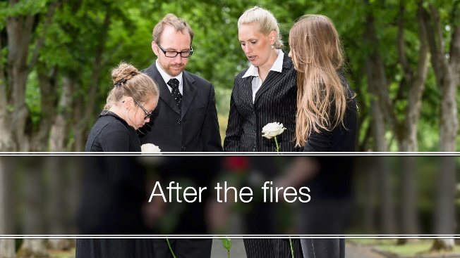  https://youtu.be/SyYYGHAZEe8?si=IEu6X3mPGcO4CgTW

Booklets in February

https://www.messagesofhope.org.au/renew-the-romance-booklet/ | 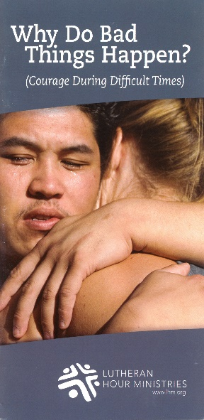  https://www.messagesofhope.org.au/bad-things-happen/
WORSHIP ONLINE & DVDs

Online, DVD & CD worship services are available at www.lutheranmedia.org.au/
worship or email luthmedia@lca.org.au or
call 1800 353 350.

