
Messages of Hope in April 2024

7th April | Peace Beyond Reason | (Interview)
Are you at peace? This week Noel Due will be talking about Peace. Not the dream of world peace, but about inner peace. Peace that works even when the world, and perhaps even you, are in chaos.

14th April | Disagreeing Well | (Interview)
Are there some people you always seem to have conflict with? How do you respond? Hear Chris Mann, leadership coach and pastor, share his thoughts on disagreeing well.
21st April | Living Amongst Floods | (Interview)
“For us to be caught in the floods, the biggest thing was that we couldn't leave.” Listen to Charmaine share her story about being trapped in the NSW floods.
28th April | Love in Action – Overseas Aid | (Jonathan Krause)
Hear Jonathan Krause share how Australian aid organisations support people overseas and how we can be a part of the hope they provide.
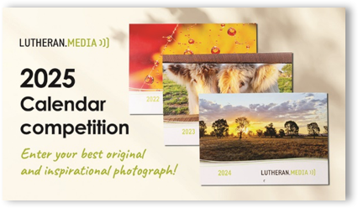
Lutheran Media 2025 Calendar Competition
The Lutheran Media Calendar Competition for 2025 is now open!
Do you have an inspiring and original photo you would like to see featured in our calendar?
Go to lutheranmedia.org.au/calendar-competition to enter in the competition for your chance to win one of three prizes.
Partner with us in inspiring others with messages of hope! For more information, call 1800 353 350 or go to the website for full terms and conditions.

Prayer Requests
For people seeking peace
For relationships to be reconciled
For those recovering from disaster

Videos in April

  https://youtu.be/zZ4WRIRLjlQ | 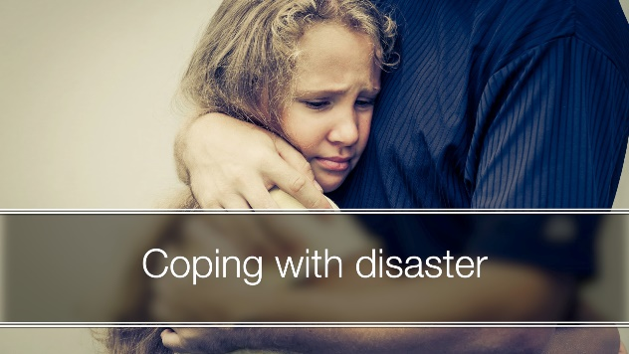  https://youtu.be/lHZ4AcEHXjM?si=m0bEj6f3AVJ0tZ2v

Booklets in April

  There’s more to anger than getting mad  https://www.messagesofhope.org.au/product/there-is-more-to-anger-than-getting-mad/ | 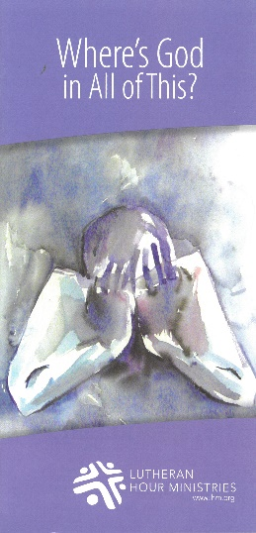  Where’s God in all of this?  https://www.messagesofhope.org.au/wheres-god-in-all-of-this-booklet/

VIDEO SERMONS

Looking for a sermon to watch or use in worship?
Videoed sermons are available for you to download and use at www.lutheranmedia.org.au/worship
WORSHIP ONLINE & DVDs

Online, DVD & CD worship services are available at www.lutheranmedia.org.au/worship or email luthmedia@lca.org.au or
call 1800 353 350.

